PC Security

Robert Gabriel

Lab 2

# Task 1: Patching your OS: Write a paragraph on the importance of patching your computer systems. This should include your OS, browser and end-user applications.

Simply put, software updates whether big or small are important. Much like with changing the oil in your car, brushing your teeth daily or going to a doctor for annual checkups, updates are necessary. Computers and the software they house require regular updates to ensure they continue to run safely and efficiently.

Viruses are ever-evolving, which too means your operating system, antivirus and other applications should continuously evolve as well. It’s quite easy to ignore system updates for a while and fall behind the times, becoming vulnerable to new threats.

Updates serve a number of different functions as listed below:

* Fix security holes
* Optimize the utilization of resources on the operating system
* Add newer and more secure features
* Remove old and unprotected features
* Update drivers to increase software efficiency
* How new browser versions benefit you and your company:
* Increased security benefits
* Avoid compatibility problems associated with older versions
* Allow your applications to work more smoothly and efficiently
* Allow access to the newest applications
* Many new websites function only in newer browser versions

Updates aren’t requested simply because. They add value to an experience you paid for from the start. You bought Microsoft Windows, your antivirus and the drivers that keep your computer working. Developers are interested in keeping their software up to date and fully functional, which is an opportunity you should jump on. Why not take advantage of new features when they’re made available if you’ve already paid for them?

Patching is meant largely as a preventative measure rather than a curative one. While you may not always be aware of future or present threats, the developers who produce these updates make their livelihood in knowing about these risks.

Software patches and updates serve a very obvious function, despite how annoying their delivery vehicle may be. Getting those alerts may feel like having a fly always buzzing around your head, but they’re a necessary annoyance. No one likes going to the doctor, but as with software updates, it needs to happen to prevent sickness and disease. Keeping your software updated to the most recent version could save your computer and your personal information.

So go ahead, follow Google’s lead. If you’re looking to enhance your online security and efficiency, update your browsers to the latest versions.

# Task 2: Automatic updates , Show how you would check for updates. Show how you would set up Automatic Updates.

## Check for updates.

1. Clicking the **Start** button. In the search box, type **Update**, and then, in the list of results, click **Windows Update**.
2. 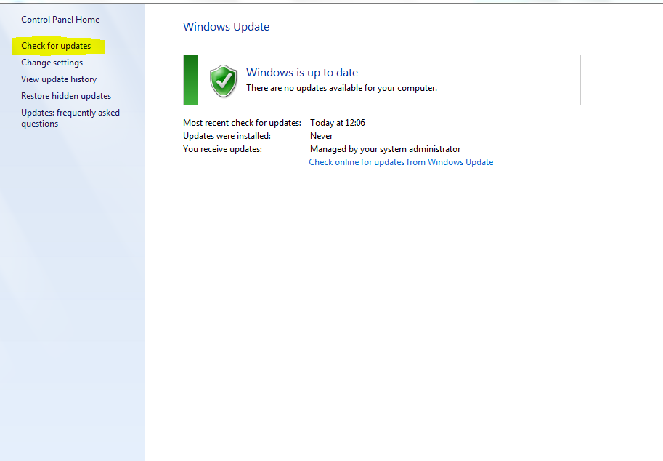In the left pane, click **Check for updates**, and then wait while Windows looks for the latest updates for your computer.
3. If you see a message telling you that important updates are available, or telling you to review important updates, click the message to view and select the important updates to install.
4. In the list, click the important updates for more information. Select the check boxes for any updates that you want to install, and then click **OK**.

# To enable Automatic Updates

1. Use Microsoft Internet Explorer to visit Microsoft Update.
2. On the right side of the page, Internet Explorer displays the current status of Automatic Updates:
   * If Automatic Updates is turned on, your computer is protected. Windows XP will automatically install updates. You don’t need to follow the rest of these steps.
   * If Automatic Updates is turned off, click **Turn on Automatic Updates**.
3. In the **Automatic Updates** window, click **OK**.

# Task 3: Microsoft Baseline Security Analyser (15 marks)

# What is MBSA used for?

Microsoft Baseline Security Analyzer (MBSA) is a software tool released by Microsoft to determine security state by assessing missing security updates and less-secure security settings within Microsoft Windows, Windows components such as Internet Explorer, IIS web server, and products Microsoft SQL Server, and Microsoft Office macro settings.

# Download, Install and run MBSA against your machine and discuss the results.

# Discuss some of the items scanned for in the Windows check portion of the scan.

# Task 4: (10 marks)

# Show how to use the Windows 7 built in Backup and Restore utility, including setting up scheduled Backups.

### You can backup up a small folder to demonstrate. To back up your files

1. Open Backup and Restore by clicking the **Start** button Picture of the Start button, clicking **Control Panel**, clicking **System and Maintenance**, and then clicking **Backup and Restore**.
2. Do one of the following:
   * If you've never used Windows Backup before, click **Set up backup**, and then follow the steps in the wizard. Administrator permission required If you're prompted for an administrator password or confirmation, type the password or provide confirmation.
   * If you've created a backup before, you can wait for your regularly scheduled backup to occur, or you can manually create a new backup by clicking **Back up now**. Administrator permission required If you're prompted for an administrator password or confirmation, type the password or provide confirmation.

Backups help ensure that your files aren't permanently lost or damaged. With automatic backups, you don't have to remember to back up your files. You can change your automatic backup settings (such as how often you back up, the type of storage you use, or the types of files you back up) whenever you want.

### To set up automatic backups

If you've never used Windows Backup before, the Windows Backup wizard automatically creates a schedule for you, which you can change.

1. Open Backup and Restore by clicking the **Start** button Picture of the Start button, clicking **Control Panel**, clicking **System and Maintenance**, and then clicking **Backup and Restore**.
2. Click **Set up backup**, and then follow the steps in the wizard. Administrator permission required If you're prompted for an administrator password or confirmation, type the password or provide confirmation.